College of Agriculture and Life Sciences (CALS) Business Operations

Federal Excess Personal Property (FEPP) Program
Quick Reference Guide

(Updated November 2018)

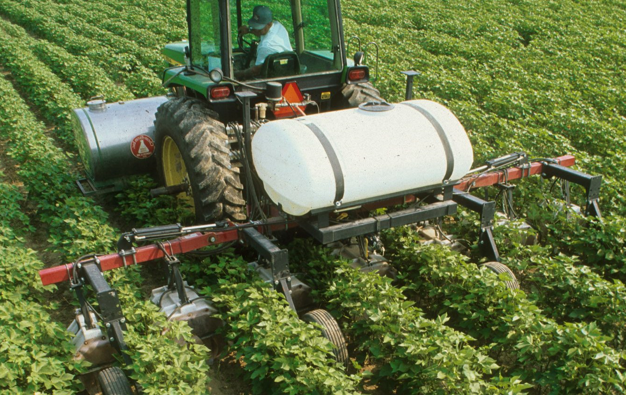

What is the FEPP program and why is it important to CALS?

Federal Excess Personal Property (FEPP) Program
The FEPP program makes use of excess federal property. This property is acquired through USDA and is only on-loan. When the property is no longer needed, the program must report it back to USDA for disposal.

The FEPP program allows CALS to save costs on equipment needed for agricultural research or extension programs. The use of FEPP property also allows CALS to make general enhancements or improvements in line with the College’s mission.

CALS Business Operations has developed a FEPP Program Standard Operating Procedures document detailing the roles and responsibilities of CALS employees associated with the FEPP program. CALS employees with a role in the FEPP program are responsible for reviewing the document and understanding their responsibilities.

Eligibility
The College of Agriculture and Life Sciences at NCSU is eligible for this program due its agricultural research and extension programs.

Program Roles
Property Custodian (PC): Oversees the use of FEPP property within their departments/stations.
FEPP Screener: A designated employee who screens available excess property for use.
FEPP Administrator: A delegated role that oversees the day-to-day operations of the FEPP program in CALS.
- The FEPP Administrator is Carolyn Richardson, the primary point of contact for the FEPP program. Please contact her at cmrichar@ncsu.edu for any FEPP program related questions or concerns.
Accountable Property Officer (APO): Carries out the policies and procedures for the personal property assigned to the FEPP program.
FEPP Coordinator (FC): A representative from USDA/ARS who provides oversight of FEPP programs and holds CALS accountable for the loaned property.

Types of Property Available (see examples in appendix)

- Vehicles
- Heavy Equipment
- Farm Equipment
- Office Furniture
- Lab Equipment
- Tools
- Various Consumable Supplies
Cost to the User
When a CALS department/unit acquires property through the FEPP program, there is a transfer cost to cover transportation, delivery, or pick up.
General Policies

  - Personal use of FEPP property is prohibited. FEPP property should not be used for anything other than approved agricultural research or extension programs. Use of FEPP property outside of the approved usage violates federal governance.
  - Property users are responsible for proper care and maintenance of FEPP property.
  - A chain of custody must be properly documented using tracking slips for all FEPP property.
  - All FEPP property must be tagged as “USDA FEPP” to distinguish between FEPP property and University property. CALS makes use of silver number labels and red ID tags. (see example in appendix)
  - Property Custodians are expected to keep their own records of property under their care. Property Custodians may be called upon at any time to provide their documentation for review.
  - Any FEPP property that is no longer needed must be reported to the FEPP Administrator for disposal.
  - FEPP property may not be disposed of by individual users or Property Custodians. All users are expected to report excess FEPP Property to the FEPP Administrator for proper disposal.
To Find Property Available Through the FEPP Program
The FEPP Program makes use of the GSAXcess system to offer up available property: www.gsaxcess.gov.
Once an employee has located a property that suits their needs, the employee should contact Carolyn Richardson at cmrichar@ncsu.edu or John Garner at jdgarner@ncsu.edu.
Responsibilities of Property Custodians
Acquisition
The Property Custodian is responsible for assessing the condition of property at the time of acquisition. The best way to determine the condition of a given property is to either ask the Owning Agency about the condition or do a physical inspection of the property.
Transportation of acquired FEPP property is to be arranged and coordinated by the Property Custodian. Please be advised that there is a 15 calendar day time limit for picking up FEPP property. A Property Custodian will likely lose access to the FEPP property if the property is not picked up within the 15 day time frame.
The Property Custodian is responsible for completing a Custodian Tracking Form when property is issued to them. The USDA/ARS expects that a clear chain of custody be established at all times.
Inventory
The USDA/ARS conducts regular review and inventory of FEPP property. The Property Custodian is responsible for keeping and maintaining their own records for property that has been issued to them.
Disposal
FEPP property is on-loan to CALS by USDA. As such, USDA has authority over the disposal process. If a Property Custodian or other property user identifies that excess property is being stored, he/she should contact the FEPP Administrator to begin the disposal process.
Under no circumstances should a Property Custodian or other property user dispose of FEPP property on their own terms. Nor should a Property Custodian or other property user send FEPP property to NCSU Surplus as this property is not owned by the University.

Appendix

- Examples of property acquired by NCSU in the past

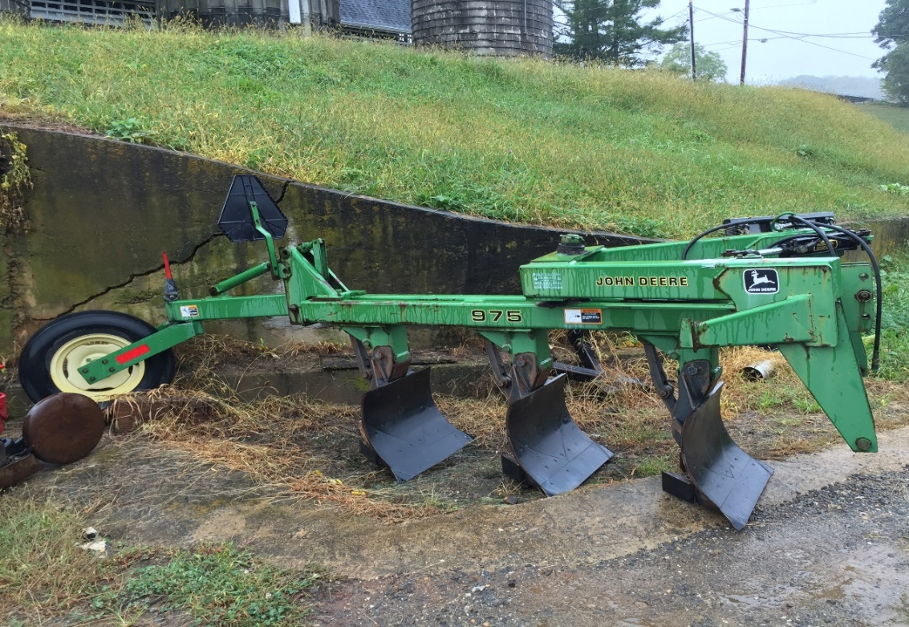

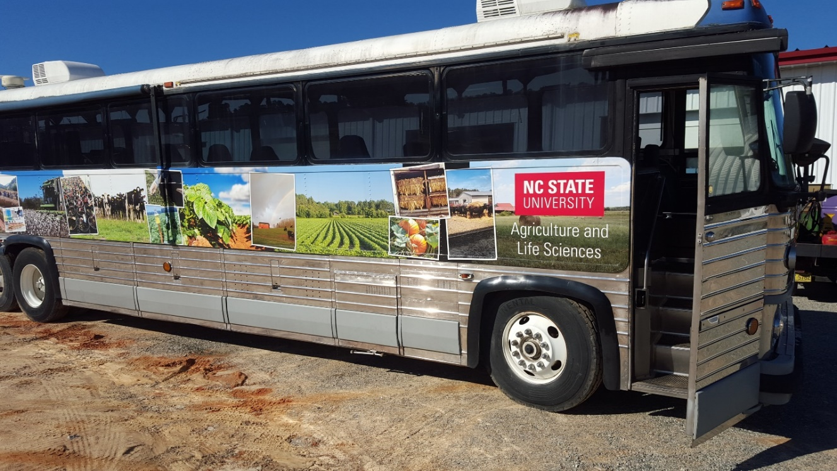
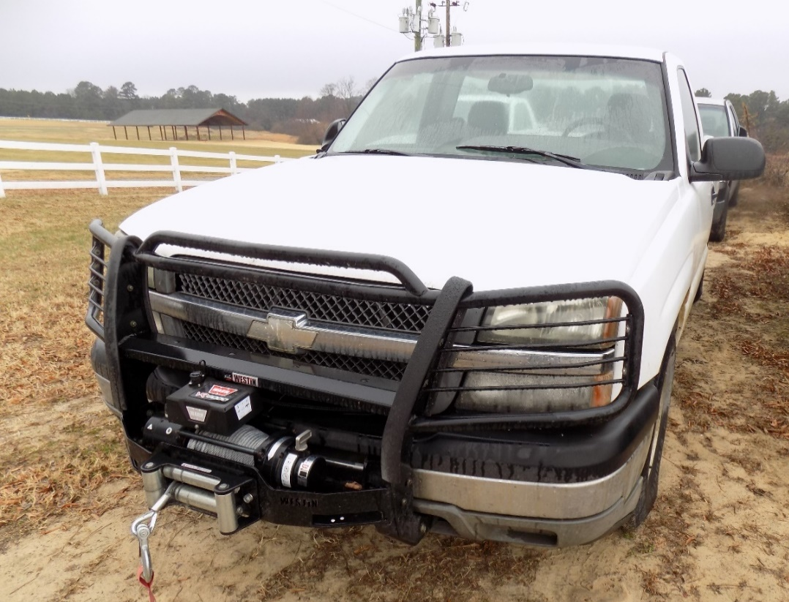

- Example of silver and red stickers used to tag FEPP property

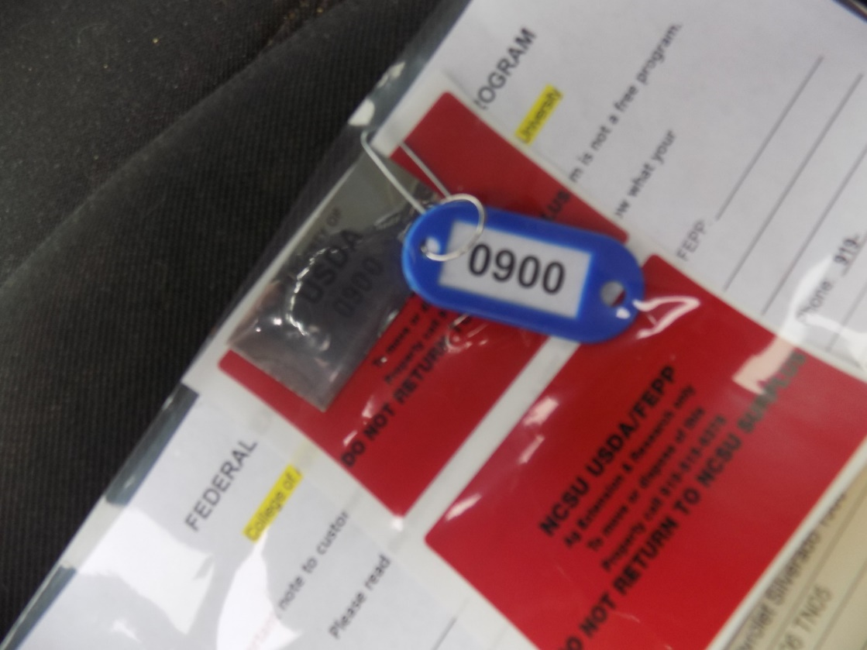

- Example of Custodian Tracking Form
