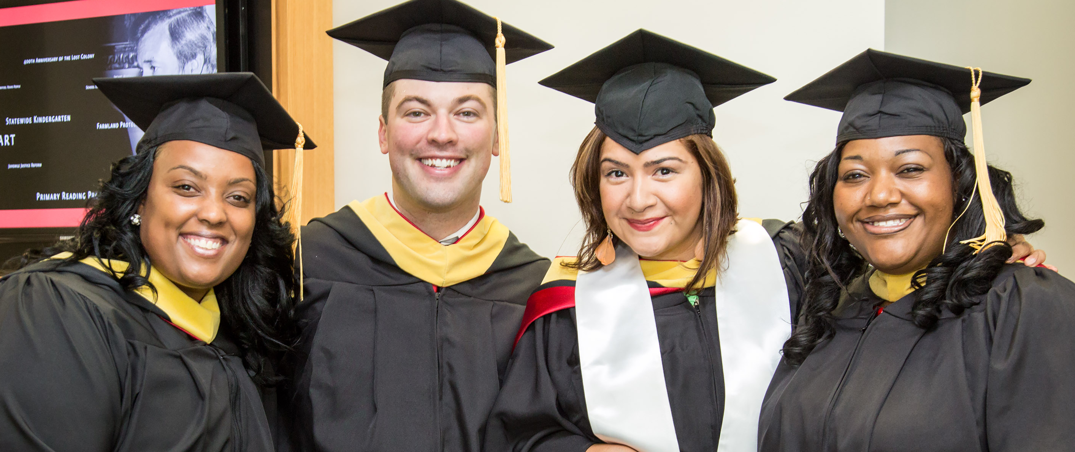
Assistant Professor and Extension Specialist
Positive Youth Development
Position Number: 00062979
Department of Agricultural and Human Sciences
Job Summary: This is a 12-month tenure track position in the Department of Agricultural and Human Sciences at North Carolina State University, at the level of Assistant Professor. The position’s effort will be 50% Academic Programs and 50% Extension. Focus on Positive Youth Development, Diversity, and Inclusion.
As an Assistant Professor, the position will be expected to develop new courses and teach current graduate level courses in Youth, Family and Community Sciences using distance education technologies. Duties of this role include:
- Teach at least 6 distance graduate courses every 2 years, including (but not limited to) YFCS 502: Theories in Youth, Family, and Community Science; YFCS 552: Program Development in Youth and Family Settings; and YFCS 553: Applied Concepts Youth Development.
- Advise YFCS MR and MS degree students.
- Coordinate Youth Development and Leadership Certificate Program.
- Serve on departmental, College, and University committees, as appropriate.
As an Extension Specialist, the position will work with county extension agents, state extension staff, and stakeholders on positive youth development programming. The position will collaborate with youth programs at the college and university level, while conducting research related to positive youth development. The position is expected to secure external funding for research and development activities. Other essential duties of this role include:
- Provide leadership on Positive Youth Development programming and serve as a specialist on diversity and inclusion in Cooperative Extension programming.
- Conduct applied research and develop Extension educational materials related to the effective and efficient integration of relevant emerging educational and communication technologies (e.g., social media, GPS, geocaching, virtual 4-H camps and clubs, etc.) into Extension educational programs for Extension youth (i.e., 4-H members, teen 4-H volunteers, etc.) and adult (i.e., adult 4-H and FCS volunteers, families, 4-H and FCS professionals, etc.) audiences.
- Teach at appropriate state 4-H in-service trainings for county 4-H professionals (e.g., Youth and Family Institutes, County 4-H Program Updates, etc.) as well as youth development partnering organizations.
- Service to appropriate professional organizations.
Applications will be reviewed at the end of November. The position will remain open until a suitable candidate is found. Earned doctorate degree in Youth Development, Human Development, Family Sciences, or a closely related field. ABD candidates who are very close to completion of their dissertations will be considered at the Instructor rank.
Apply at: https://jobs.ncsu.edu

Inclusiveness and diversity are academic imperatives and thus are university goals. We are particularly interested in candidates who have experience working with students from diverse backgrounds and a demonstrated commitment to improving access to higher education for students from underrepresented groups.

Please view our inclusion statement and the NC State University link to the Equal Opportunity and Non-Discrimination Policy.
THE YOUTH, FAMILY, AND COMMUNITY SCIENCES INCLUSION STATEMENT
The Youth, Family, and Community Sciences program supports and values diversity, equity, and inclusion. As our Chancellor says " I believe we can be an exemplary model of a community that embraces diversity, inclusion and freedom of speech; where we can disagree with and still respect one another." North Carolina State University strives to build and maintain an environment that supports and rewards individuals on the basis of relevant factors such as ability, merit and performance. Accordingly, NC State engages in equal opportunity and affirmative action efforts, and prohibits discrimination, harassment, and retaliation, as defined by this policy: https://policies.ncsu.edu/policy/pol-04-25-05/

ABOUT NC STATE UNIVERSITY
NC State is a pre-eminent research enterprise, attracting top faculty and students from around the world. With our partners, we create economic, societal and intellectual prosperity. View NC State University’s stats and strengths.

NC State University has a pretty rich history. Want to learn about this history and some fun facts about NC State University? Check out the link below to see how it all began. NC State University History & Fun Facts

The Department of Agriculture and Human Sciences is home to the YFCS Academic Program, serving students in youth development, family, and community sciences. Helping families is the right thing to do. It’s also a career. Check us out at https://yfcsonline.cals.ncsu.edu

LIVING IN RALEIGH
Raleigh was rated 7th best city to live by US News and 10th most livable city in the US by USA Today. Click the link above for information about living in Raleigh or visit http://www.visitraleigh.com/

NC STATE COOPERATIVE EXTENSION AND NC FAMILY CONSUMER SCIENCE
Click the links above for information about NC Cooperative Extension and Family Consumer Science or visit:

- NC Cooperative Extension: https://www.ces.ncsu.edu/
- NC Family Consumer Science: https://fcs.ces.ncsu.edu/

