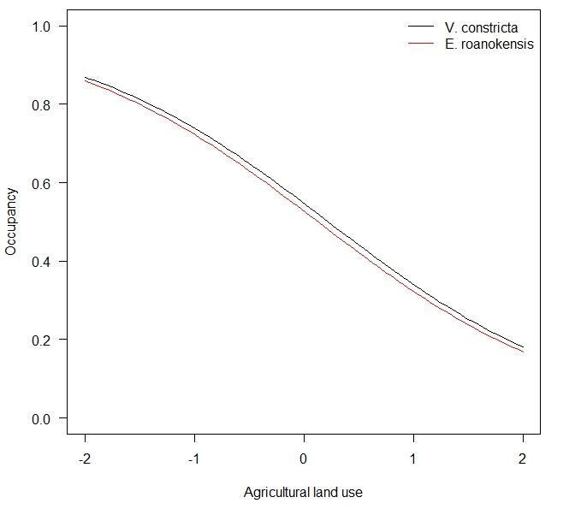
A
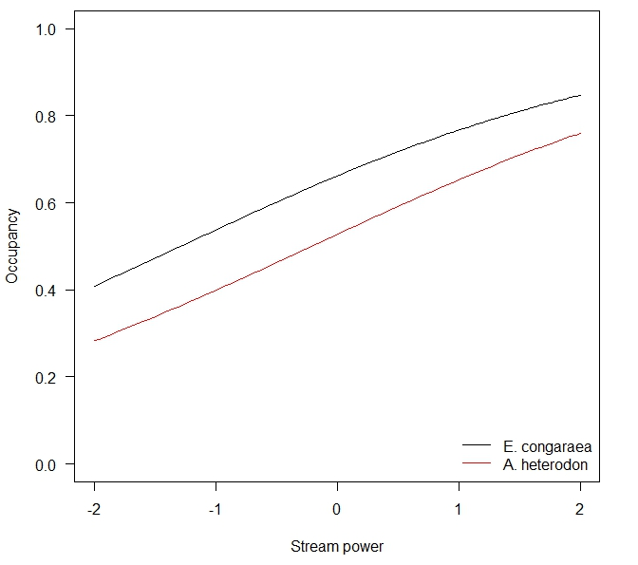
B
Fig. S1. Estimated responses in the occurrence probability of Villosa constricta and Elliptio roanokensis over a range of agricultural land use values (A) and E. congaraea and A. heterodon for a range of stream power values (B) in a catchment; see Model 2, Table S1 for model details.

