Supporting Information

Table SI 1. Fish species common name, scientific name, family, and associated abbreviation along with species-specific standard weight equation parameters for determining relative weights.
Common Name | Scientific Name | Family | Abbreviation | Intercept (a) | Slope (b) | Minimum TL (mm)
Largemouth Bass | Micropterus salmoides | Centrarchidae | LMB | –5.528 | 3.273 | 150
Smallmouth Bass | Micropterus dolomieu | Centrarchidae | SMB | –5.329 | 3.2 | 150
Spotted Bass | Micropterus punctulatus | Centrarchidae | SPB | –5.392 | 3.215 | 100
Redear Sunfish | Lepomis microlophus | Centrarchidae | RES | –4.968 | 3.119 | 70
Warmouth | Lepomis gulosus | Centrarchidae | WAR | –5.180 | 3.241 | 80
Bluegill Sunfish | Lepomis macrochirus | Centrarchidae | BLG | –5.374 | 3.316 | 80
Redbreast | Lepomis auritus | Centrarchidae | RBS | –4.755 | 2.997 | NA
Pumpkinseed | Lepomis gibbosus | Centrarchidae | PKS | –5.179 | 3.237 | 50
Channel Catfish | Ictalurus punctatus | Ictaluridae | CHC | –5.800 | 3.294 | 70
White Catfish | Ameiurus catus | Ictaluridae | WHC | –5.851 | 3.395 | 100
Blue Catfish | Ictalurus furcatus | Ictaluridae | BLC | –6.067 | 3.4 | 160
Flathead Catfish | Pylodictis olivaris | Ictaluridae | FHC | –5.542 | 3.23 | 130

Table SI 2. Full list of all contaminants analyzed. PAHs, OCPs, PCBs, CUPs, hormones, and industrial EACs were evaluated in water. PAHs, PCBs, OCPs, CUPs, and metals were analyzed in sediment. PCBs, OCPS, and metals were evaluated in fish muscle tissue. (*) indicates water detection; (+) indicates fish muscle tissue detection; (•) indicates sediment detection.
PAHs | OCPs | PCBs | CUPs | Hormones | Industrial EACs | Metals
Naphthalene *• | 2,4'-DDD | Cl2(08) | Acetochlor | 17_-Estradiol (aE2) | BisphenolA * | Aluminum (Al) +•
Acenaphthylene • | 2,4'-DDE | Cl3(18) * | alachlor | 17_-Estradiol (bE2) | Nonylphenol * | Antimony (Sb)
Acenaphthene *• | 2,4'-DDT | Cl3(28)* | Atrazine*• | 17_-Testosterone (bT) |  | Arsenic (As)
C1 – Naphthalenes *• | 4,4'-DDD *+ | Cl4(52) *+ | Atrazine-desethyl * | Epitestosterone (aT) |  | Barium (Ba) +•
C2 – Naphthalenes *• | 4,4'-DDE *+• | Cl4(44) *+ | Atrazine-desisopropyl * | Estriol (E3) |  | Berylium (Be) •
C3 – Naphthalenes *• | 4,4'-DDT | Cl4(66) *+ | Benfluralin | Estrone (E1) |  | Cadmium (Cd) •
C4 – Naphthalenes *• | Aldrin | Cl5(101) *+ | Bifenthrin | Ethinylestradiol (EE2) * |  | Cobalt (Co) •
Fluorene *• | alpha-BHC | Cl4(77) | Butylate |  |  | Chromium (Cr) •
C1 – Fluorenes *• | betaBHC | Cl5(118) *+ | Chlorothalonil |  |  | Copper (Cu) +•
C2 – Fluorenes * | Chlorothalonil | Cl6(153) *+ | Chlorpyrifos |  |  | Iron (Fe) +•
C3 – Fluorenes * | Chlorpyrifos * | Cl5(105) *+ | Cyfluthrin |  |  | Mercury (Hg) +•
Dibenzothiophene • | cis-Chlordane *+• | Cl6(138) *+ | Cypermethrin |  |  | Potassium (K) +•
C1 – Dibenzothiophene *• | Delta-BHC | Cl5(126) | Dacthal |  |  | Magnesium (Mg) +•
C2 – Dibenzothiophene *• | Dieldrin | Cl7(187) + | Deltamethrin |  |  | Manganese (Mn) +•
C3 – Dibenzothiophene *• | Endosulfan I | Cl6(128) + | Diazinon |  |  | Molybdenum (Mo)
Phenanthrene *• | Endosulfan II | Cl8(201) | Dimethenamid * |  |  | Nickel (Ni) +•
Anthracene *• | Endosulfan Sulfate | Cl7(180) + | Dimethoate |  |  | Lead (Pb) +•
C1 - Phenanthrenes/Anthracenes *• | Endrin | Cl7(170) + | EPTC |  |  | Selenium (Se) +
C2 - Phenanthrenes/Anthracenes *• | Endrin Aldehyde | Cl8(195) | Esfenvalerate |  |  | Silicon (Si) +•
C3 - Phenanthrenes/Anthracenes *• | Endrin Ketone | Cl9(206) + | Ethalfluralin |  |  | Strontium (Sr) +•
C4 - Phenanthrenes/Anthracenes *• | gamma-BHC (Lindane) | Cl10(209) + | Ethopropyl |  |  | Vanadium (V) •

Table SI 2-continued.
PAHs | OCPs | PCBs | CUPs | Hormones | Industrial EACs | Metals
Fluoranthene *• | Heptachlor * |  | Fenpropathrin |  |  | Zinc (Zn) +•
Pyrene *• | Heptachlor epoxide * |  | Flumetralin
C1 - Fluoranthenes/Pyrene *• | Hexachlorobenzene *+• |  | Fonofos
C2 - Fluroanthrene/Pyrene *• | Methoxychlor |  | lambda cyhalothrin
C3 - Fluoranthrene/Pyrene • | Mirex |  | Malathion
Retene *• | Trans-Chlordane *+• |  | Methidathion
Benz[a]anthracene *• | Trans-Nonachlor *+• |  | Methyl parathion
Chrysene *• |  |  | Metolachlor *
C1 - Chrysenes *• |  |  | Metribuzin
C2 - Chrysenes *• |  |  | Napropamide
C3 – Chrysenes • |  |  | Pebulate
C4 – Chrysenes • |  |  | Pendimethalin
Benzo[b]fluoranthene *• |  |  | Permethrin
Benzo[k]fluoranthene *• |  |  | Phorate
Benzo[e]pyrene *• |  |  | Phosmet
Benzo[a]pyrene • |  |  | Prometon *
Perylene *• |  |  | Propachlor
Indeno[1,2,3-cd]pyrene • |  |  | Propazine *
Dibenz[a,h,]anthracene • |  |  | Propiconazole
Benzo[g,h,i]perylene *• |  |  | Simazine *
Coronene • |  |  | Tebuthiuron
 |  |  | Terbufos
 |  |  | Triallate
 |  |  | Tribufos
 |  |  | Trichlorfon
 |  |  | Trifluralin

Table SI 3. Water (ng/L) and sediment (ng/g DW) organic contaminant concentrations at each site. Values in with an asterisk (*) exceed published thresholds for aquatic life (Caldwell et al., 2012; US EPA, 2005; Aschberger et al., 2010; MacDonald et al., 2000; US EPA, 2006; Wu et al., 2014; US EPA, 2016). NA: no known detection limit or threshold exists. DL: detection limit (i.e., practical quantitation limit). BDL: below detection limit.

 |  |  |  | Site Concentration
 | Contaminant | DL | Threshold | Kerr Scott R. | Ronda | Route 801 | Badin Lake | Red Hill | Blewett Lake | 74 Bridge | Digg's Tract | Society Hill | Pee Dee | Bucksport
Water  (ng/L) | PAHs | 0.2 | NA | 128.60 | 105.22 | 219.00 | 152.47 | 118.86 | 72.60 | 95.23 | 134.48 | 238.25 | 159.44 | 113.70
 | OCPs | 0.2 | NA | 0.26 | 1.64 | 5.01 | 1.67 | 12.29 | 2.83 | 3.05 | 3.46 | 5.29 | 4.53 | 1.85
 | PCBs | 0.2 | 14 | 0.03 | 0.04 | 0.35 | 0.04 | 1.36 | 0.63 | 0.92 | 4.92 | 6.67 | 7.31 | 1.47
 | CUPs | 0.5 | NA | BDL | 3.16 | 39.36 | 24.04 | 153.99 | 20.18 | 315.55 | 74.07 | 205.05 | 190.66 | 29.38
 | EE2 | 0.1 | 0.1 | BDL | BDL | BDL | BDL | 0.62* | 1.35* | 1.97* | 0.84* | 0.33* | 1.62* | 0.27*
 | Nonylphenol | 0.1 | 6600 | 0.85 | 0.56 | 0.70 | 0.40 | 0.21 | 0.97 | 3.10 | 2.40 | 4.60 | 3.50 | 1.40
 | BPA | 0.1 | 1500 | BDL | BDL | 0.62 | 0.40 | 0.89 | 0.65 | 1.40 | 1.90 | 2.51 | 1.05 | 2.27
 | E2β-Eq. | NA | 0.73 | 0.269 | 0.507 | 0.895* | 0.212 | 0.103 | 0.282 | 1.259* | 0.118 | 0.351 | 0.533 | 0.320
Sediment (ng/g DW) | PAHs | 1.0 | 1610 | 1.66 | 349.73 | 2960.20* | 11068.05* | 595.33 | 7.34 | 383.48 | 1343.62 | 237.26 | 210.94 | 336.66
 | OCPs | 0.1 | NA | BDL | BDL | 2.28 | 101.49 | 1.06 | BDL | 0.99 | 2.81 | 0.74 | 0.49 | BDL
 | PCBs | 0.1 | 59.8 | BDL | BDL | BDL | 1.03 | 2.97 | BDL | 0.15 | 5.18 | 0.48 | BDL | BDL
 | Atrazine | 2.0 | 6.62 | BDL | BDL | BDL | BDL | 3.80 | 0.70 | 0.85 | BDL | BDL | BDL | 3.40

Table SI 4. Sediment concentrations (ug/g DW) of metals detected at each site. Values with a (*) indicate a TEC/LEL threshold has been exceeded. Values with a (⌃) indicate a PEC/SEL threshold has been exceeded. DL: detection limit (ug/g DW). TEC: threshold effect concentration (ug/g DW; MacDonald et al., 2000). LEL: lowest effect level (ug/g DW; Persaud and Jaagumagi, 1993). PEC: predicted effect concentration (ug/g DW; MacDonald et al., 2000). SEL: severe effect level (ug/g DW; Persaud and Jaagumagi, 1993). + indicates a LEL or SEL threshold. BDL: below detection limit.

 |  |  |  | Site
Metal | DL | TEC/ LEL+ | PEC/ SEL+ | Kerr Scott R. | Ronda | Route 801 | Badin Lake | Red Hill | Blewett Lake | 74 Bridge | Digg's Tract | Society Hill | Pee Dee | Buck-sport
Aluminum (Al) | 0.5 | NA | NA | 1656.0 | 659.0 | 1505.8 | 1011.6 | 1192.8 | 393.7 | 687.3 | 1620.8 | 859.1 | 836.8 | 1086.3
Barium (Ba) | 0.25 | NA | NA | 98.3 | 49.4 | 113.8 | 108.7 | 85.9 | 34.2 | 64.1 | 177.3 | 95.7 | 73.6 | 90.2
Berylium (Be) | 0.25 | NA | NA | 0.4 | BDL | 0.7 | BDL | 0.5 | BDL | BDL | 0.9 | 0.5 | 0.5 | 0.6
Cadmium (Cd) | 0.25 | 0.99 | 4.98 | 2.3* | 1.1* | 2.7* | 4.2* | 2.9* | 1.2* | 1.7* | 3.6* | 1.9* | 1.8* | 2.0*
Cobalt (Co) | 0.25 | NA | NA | 8.7 | 4.8 | 10.3 | 15.7 | 8.5 | 4.2 | 6.2 | 15.9 | 8.4 | 7.4 | 6.9
Chromium (Cr) | 0.25 | 43.4 | 111 | 6.8 | 10.6 | 24.5 | 14.4 | 19.5 | 8.2 | 12.3 | 26.1 | 15.5 | 15.6 | 19.1
Copper (Cu) | 0.25 | 31.6 | 149 | 8.0 | 6.4 | 17.8 | 41.5 | 21.1 | 2.7 | 10.3 | 25.8 | 12.5 | 10.1 | 12.3
Iron (Fe) | 0.5 | 20,000+ | NA | 2226.6 | 1032.9 | 2446.8 | 3591.5 | 2617.8 | 1109.4 | 1435.6 | 3155.8 | 1693.3 | 1597.8 | 1797.3
Mercury (Hg) | 0.001 | 0.18 | 1.06 | 0.016 | 0.006 | 0.024 | 0.076 | 0.053 | 0.003 | 0.022 | 0.062 | 0.029 | 0.014 | 0.028
Potassium (K) | 0.5 | NA | NA | 4424.6 | 1475.6 | 2183.5 | 274.3 | 554.0 | 1879.9 | 711.4 | 906.7 | 747.2 | 890.3 | 812.9
Magnesium (Mg) | 0.5 | NA | NA | 3500.5 | 1829.9 | 3264.2 | 945.9 | 1908.6 | 1457.1 | 1218.1 | 2416.2 | 1549.5 | 1797.3 | 1929.6
Manganese (Mn) | 0.25 | 460+ | 1100+ | 210.0 | 107.4 | 540.3* | 759.1* | 724.3* | 100.0 | 424.3 | 2595.3⌃ | 920.5* | 458.2 | 226.1
Nickel (Ni) | 0.25 | 22.7 | 48.6 | BDL | BDL | 5.0 | 4.8 | 7.9 | BDL | 3.3 | 11.8 | 5.9 | 4.7 | 6.4
Lead (Pb) | 0.25 | 35.8 | 128 | 6.4 | 4.4 | 13.3 | 13.2 | 9.8 | 3.7 | 6.9 | 15.2 | 8.1 | 8.7 | 9.0
Silicon (Si) | 0.5 | NA | NA | 1041.5 | 638.2 | 1314.8 | 1573.2 | 544.0 | 478.7 | 809.1 | 1263.5 | 1116.7 | 916.2 | 858.8
Strontium (Sr) | 0.25 | NA | NA | 9.9 | 4.0 | 16.3 | 40.3 | 12.2 | 2.3 | 7.9 | 21.1 | 10.1 | 8.1 | 8.5
Vanadium (V) | 0.25 | NA | NA | 25.6 | 14.6 | 38.4 | 83.0 | 37.8 | 17.6 | 22.4 | 46.8 | 26.7 | 24.8 | 28.4
Zinc (Zn) | 0.25 | 121 | 459 | 44.2 | 30.8 | 65.2 | 31.0 | 28.3 | 16.2 | 28.9 | 71.3 | 38.0 | 35.6 | 42.7

Table SI 5. Average contaminant concentrations and average percent moisture in fish muscle tissue for each species at each site. PCBs, 4'4-DDE, and OCPs measured in ng/g WW. Hg in ug/g WW. NA=not applicable. SD=standard deviation. n=sample size.

 |  |  | % Moisture |  |  | PCBs |  |  | OCPs |  |  | 4'4-DDE |  |  | Hg
Site | Species | n | Mean | SD |  | Mean | SD |  | Mean | SD |  | Mean | SD |  | Mean | SD
Kerr Scott R. | Micropterus salmoides | 3 | 75.706 | 6.385 |  | 1.420 | 1.490 |  | 1.679 | 1.864 |  | 0.661 | 0.919 |  | 0.344 | 0.209
 | Lepomis microlophus | 1 | 80.024 | NA |  | 1.123 | NA |  | 0.476 | NA |  | 0.285 | NA |  | 0.049 | NA
 | Lepomis macrochirus | 2 | 81.515 | 0.530 |  | 0.621 | 0.249 |  | 1.308 | 0.613 |  | 0.78 | 0.452 |  | 0.048 | 0.004
 | Ictalurus catus | 3 | 83.212 | 1.047 |  | 4.018 | 1.643 |  | 4.159 | 1.749 |  | 2.125 | 0.783 |  | 0.218 | 0.111
Ronda | Micropterus punctulatus | 3 | 79.931 | 0.483 |  | 1.407 | 0.310 |  | 1.441 | 0.366 |  | 0.944 | 0.275 |  | 0.176 | 0.028
 | Lepomis auritus | 2 | 81.709 | 1.603 |  | 0.368 | 0.203 |  | 0.443 | 0.124 |  | ND | NA |  | 0.062 | 0.01
 | Ictalurus punctatus | 1 | 82.272 | NA |  | 2.163 | NA |  | 2.720 | NA |  | 1.623 | NA |  | 0.386 | NA
Route 801 | Ictalurus punctatus | 1 | 78.421 | NA |  | 14.566 | NA |  | 25.675 | NA |  | 15.542 | NA |  | 0.174 | NA
 | Ictalurus furcatus | 1 | 79.715 | NA |  | 9.258 | NA |  | 15.795 | NA |  | 9.615 | NA |  | 0.21 | NA
Badin Lake | Micropterus salmoides | 3 | 73.942 | 10.652 |  | 6.688 | 0.856 |  | 12.035 | 1.606 |  | 9.241 | 1.067 |  | 0.326 | 0.041
 | Lepomis macrochirus | 3 | 81.045 | 0.116 |  | 3.188 | 0.834 |  | 3.262 | 1.135 |  | 2.823 | 1.054 |  | 0.039 | 0.003
 | Ictalurus catus | 2 | 85.260 | 4.945 |  | 1.763 | 1.561 |  | 2.646 | 2.375 |  | 1.93 | 1.688 |  | 0.034 | 0.008
Red Hill | Micropterus salmoides | 1 | 79.180 | NA |  | 4.174 | NA |  | 3.265 | NA |  | 2.713 | NA |  | 0.209 | NA
 | Lepomis macrochirus | 2 | 80.007 | 0.232 |  | 1.070 | 0.277 |  | 1.313 | 0.308 |  | 1.011 | 0.155 |  | 0.04 | 0.003
 | Ictalurus furcatus | 3 | 78.980 | 5.505 |  | 6.421 | 5.042 |  | 3.422 | 3.910 |  | 2.526 | 2.503 |  | 0.129 | 0.044
Blewett Lake | Micropterus salmoides | 5 | 76.472 | 2.463 |  | 8.022 | 1.674 |  | 5.664 | 1.963 |  | 4.559 | 1.440 |  | 0.198 | 0.064
 | Lepomis macrochirus | 3 | 81.111 | 0.959 |  | 2.243 | 0.282 |  | 1.712 | 0.102 |  | 1.364 | 0.083 |  | 0.051 | 0.007
 | Ictalurus punctatus | 2 | 78.120 | 4.291 |  | 7.137 | 3.039 |  | 4.475 | 1.476 |  | 3.955 | 1.565 |  | 0.178 | 0.103

Table SI 5-continued.

 |  |  | % Moisture |  |  | PCBs |  |  | OCPs |  |  | 4'4-DDE |  |  | Hg
Site | Species | n | Mean | SD |  | Mean | SD |  | Mean | SD |  | Mean | SD |  | Mean | SD
74 Bridge | Micropterus salmoides | 3 | 80.238 | 2.017 |  | 7.25 | 4.988 |  | 7.262 | 6.416 |  | 5.67 | 4.501 |  | 0.167 | 0.03
 | Lepomis auritus | 3 | 81.034 | 0.0652 |  | 7.389 | 0.931 |  | 4.201 | 0.83 |  | 3.427 | 0.745 |  | 0.047 | 0.005
 | Lepomis microlophus | 1 | 81.456 | NA |  | 7.376 | NA |  | 0.351 | NA |  | 0.351 | NA |  | 0.158 | NA
 | Ictalurus punctatus | 3 | 72.437 | 5.639 |  | 28.879 | 32.2 |  | 17.817 | 18.558 |  | 11.129 | 12.085 |  | 0.084 | 0.004
Digg's Tract | Micropterus salmoides | 3 | 79.033 | 0.508 |  | 10.834 | 9.996 |  | 8.799 | 8.46 |  | 6.536 | 5.918 |  | 0.22 | 0.071
 | Lepomis microlophus | 3 | 75.290 | 8.791 |  | 6.882 | 5.122 |  | 1.369 | 0.378 |  | 0.888 | 0.775 |  | 0.091 | 0.07
 | Ictalurus furcatus | 3 | 70.641 | 8.403 |  | 54.452 | 36.258 |  | 6.896 | 4.711 |  | 4.547 | 3.179 |  | 0.171 | 0.083
 | Ictalurus punctatus | 1 | 71.773 | NA |  | 71.773 | NA |  | 3.825 | NA |  | 2.578 | NA |  | 0.085 | NA
Society Hill | Micropterus salmoides | 3 | 78.985 | 0.134 |  | 18.396 | 20.874 |  | 3.726 | 0.677 |  | 3.171 | 0.348 |  | 0.209 | 0.053
 | Lepomis macrochirus | 3 | 80.580 | 0.129 |  | 1.065 | 0.703 |  | 0.877 | 0.1 |  | 0.745 | 0.095 |  | 0.058 | 0.026
 | Ictalurus furcatus | 3 | 78.141 | 6.769 |  | 3.377 | 2.465 |  | 1.665 | 0.6 |  | 1.357 | 0.419 |  | 0.121 | 0.017
Pee Dee | Micropterus salmoides | 3 | 77.938 | 1.291 |  | 4.187 | 0.461 |  | 3.069 | 1.472 |  | 2.494 | 1.06 |  | 0.526 | 0.159
 | Lepomis macrochirus | 3 | 79.882 | 2.204 |  | 1.898 | 2.333 |  | 1.525 | 1.781 |  | 1.022 | 1.209 |  | 0.074 | 0.009
 | Ictalurus furcatus | 3 | 79.921 | 0.709 |  | 4.933 | 0.766 |  | 0.987 | 0.876 |  | 0.641 | 1.11 |  | 0.362 | 0.209
Bucksport | Micropterus salmoides | 3 | 72.487 | 4.391 |  | 1.638 | 1.184 |  | 2.123 | 1.457 |  | 1.777 | 1.142 |  | 0.666 | 0.16
 | Lepomis macrochirus | 3 | 78.665 | 0.422 |  | 0.376 | 0.458 |  | 0.446 | 0.666 |  | 0.348 | 0.602 |  | 0.27 | 0.092
 | Ictalurus furcatus | 3 | 80.627 | 1.498 |  | 10.898 | 13.634 |  | 3.343 | 4.483 |  | 2.787 | 3.539 |  | 0.406 | 0.184

Table SI 6. PAH ESBTU calculations for water at each site.

 | Site
PAH | Kerr S. R. | Ronda | Rt. 801 | Badin Lake | Red Hill | Blewett Lake | 74 Bridge | Digg's Tract | Society Hill | Pee Dee | Bucksport
Naphthalene | 0.0 | 0.6 | 0.4 | 0.5 | 1.1 | 0.4 | 0.4 | 0.3 | 1.0 | 1.6 | 0.9
Acenaphthylene | 0.0 | 0.0 | 0.0 | 0.0 | 0.0 | 0.0 | 0.0 | 0.0 | 0.0 | 0.0 | 0.0
Acenaphthene | 0.0 | 1.0 | 1.2 | 0.0 | 0.5 | 0.1 | 0.1 | 0.7 | 0.7 | 0.3 | 0.1
C1 - Naphthalenes | 1.0 | 0.7 | 0.8 | 1.1 | 1.0 | 0.4 | 0.4 | 0.6 | 1.0 | 1.7 | 0.7
C2 - Naphthalenes | 5.4 | 3.1 | 3.5 | 5.2 | 2.6 | 1.1 | 1.4 | 2.2 | 2.9 | 1.9 | 1.6
C3 - Naphthalenes | 25.0 | 8.3 | 8.2 | 17.4 | 6.0 | 3.2 | 4.2 | 5.2 | 7.8 | 3.5 | 3.9
C4 - Naphthalenes | 22.1 | 7.9 | 8.7 | 21.4 | 12.1 | 4.7 | 6.4 | 6.5 | 14.8 | 7.3 | 7.0
Fluorene | 0.3 | 1.1 | 1.3 | 0.4 | 0.4 | 0.1 | 0.3 | 0.9 | 0.7 | 0.3 | 0.2
C1 - Fluorenes | 7.9 | 2.8 | 3.1 | 5.1 | 3.0 | 1.7 | 1.7 | 2.5 | 3.5 | 1.6 | 1.4
C2 - Fluorenes | 15.6 | 5.8 | 8.4 | 14.2 | 7.7 | 3.9 | 4.8 | 5.1 | 16.6 | 6.6 | 5.0
C3 - Fluorenes | 12.0 | 5.2 | 8.3 | 10.1 | 5.4 | 2.8 | 4.1 | 5.4 | 25.8 | 12.4 | 5.3
Dibenzothiophene | 0.0 | 0.0 | 0.0 | 0.0 | 0.0 | 0.0 | 0.0 | 0.0 | 0.0 | 0.0 | 0.0
C1 - Dibenzothiophene | 0.4 | 0.8 | 2.8 | 0.0 | 0.9 | 0.4 | 0.6 | 0.9 | 1.4 | 0.0 | 0.0
C2 - Dibenzothiophene | 0.0 | 1.5 | 2.5 | 0.0 | 2.4 | 1.1 | 1.6 | 2.3 | 7.8 | 2.5 | 1.1
C3 - Dibenzothiophene | 0.0 | 1.7 | 2.5 | 0.0 | 2.0 | 1.3 | 1.4 | 2.1 | 8.7 | 4.2 | 1.7
Phenanthrene | 1.0 | 6.8 | 9.9 | 1.0 | 3.8 | 1.0 | 1.3 | 5.8 | 3.8 | 1.3 | 0.7
Anthracene | 0.2 | 0.5 | 0.8 | 0.5 | 0.5 | 0.3 | 0.3 | 0.6 | 0.6 | 0.4 | 0.2
C1 - P/A | 8.5 | 5.3 | 15.2 | 7.7 | 6.3 | 2.7 | 3.6 | 7.5 | 8.8 | 4.4 | 3.4
C2 - P/A | 11.5 | 6.5 | 14.2 | 12.5 | 6.9 | 3.3 | 5.1 | 7.8 | 18.9 | 11.0 | 5.9
C3 - P/A | 5.2 | 0.0 | 11.6 | 7.7 | 6.1 | 3.7 | 5.2 | 5.9 | 18.1 | 12.0 | 7.6
C4 - P/A | 0.0 | 0.0 | 0.0 | 2.8 | 0.0 | 0.0 | 0.0 | 0.0 | 0.0 | 0.0 | 0.0
Fluoranthene | 5.0 | 15.3 | 30.2 | 9.9 | 16.0 | 8.9 | 10.9 | 21.1 | 20.0 | 13.0 | 6.6
Pyrene | 2.7 | 11.6 | 19.8 | 12.3 | 9.7 | 5.5 | 8.0 | 15.2 | 15.2 | 10.7 | 5.7
C1 - F/P | 1.9 | 2.8 | 5.9 | 5.2 | 3.8 | 2.4 | 3.0 | 4.9 | 8.8 | 6.4 | 3.3
C2 - F/P | 0.0 | 2.0 | 3.3 | 3.5 | 2.5 | 1.6 | 2.2 | 3.1 | 4.4 | 4.1 | 2.4
C3 - F/P | 0.0 | 0.0 | 0.0 | 0.0 | 0.0 | 0.0 | 0.0 | 0.0 | 0.0 | 0.0 | 0.0
Retene | 1.6 | 7.9 | 41.9 | 1.7 | 8.2 | 4.7 | 6.5 | 8.4 | 23.0 | 26.4 | 28.2
Benz[a]anthracene | 0.0 | 1.1 | 1.5 | 1.4 | 0.0 | 0.0 | 0.8 | 1.5 | 1.8 | 1.2 | 0.8

Table SI 6-continued.

 | Site
PAH | Kerr S. R. | Ronda |  | Route 801 |  | Badin Lake | Red Hill |  | Blewett Lake |  |  | 74 Bridge | Digg's Tract | Society Hill | Pee Dee | Bucksport
Chrysene | 0.3 | 1.6 |  | 3.9 |  | 1.5 | 0.0 |  | 0.0 |  |  | 2.8 | 4.1 | 5.1 | 4.7 | 1.7
C1 - Chrysenes | 0.3 | 0.6 |  | 1.3 |  | 1.1 | 0.0 |  | 0.0 |  |  | 0.9 | 1.1 | 1.6 | 1.2 | 0.0
C2 - Chrysenes | 0.0 | 0.0 |  | 0.7 |  | 0.6 | 0.0 |  | 0.0 |  |  | 0.0 | 0.6 | 0.8 | 0.7 | 0.0
C3 - Chrysenes | 0.0 | 0.0 |  | 0.0 |  | 0.0 | 0.0 |  | 0.0 |  |  | 0.0 | 0.0 | 0.0 | 0.0 | 0.0
C4 - Chrysenes | 0.0 | 0.0 |  | 0.0 |  | 0.0 | 0.0 |  | 0.0 |  |  | 0.0 | 0.0 | 0.0 | 0.0 | 0.0
Benzo[b]fluoranthene | 0.0 | 0.0 |  | 2.6 |  | 2.7 | 1.9 |  | 1.1 |  |  | 1.4 | 1.7 | 2.0 | 2.1 | 0.9
Benzo[k]fluoranthene | 0.0 | 0.0 |  | 0.6 |  | 0.6 | 0.3 |  | 0.2 |  |  | 0.3 | 0.4 | 0.4 | 0.3 | 0.1
Benzo[e]pyrene | 0.3 | 0.8 |  | 1.6 |  | 1.9 | 1.2 |  | 0.0 |  |  | 0.0 | 1.1 | 1.5 | 1.9 | 0.0
Benzo[a]pyrene | 0.0 | 0.0 |  | 0.0 |  | 0.0 | 0.0 |  | 0.0 |  |  | 0.0 | 0.0 | 0.0 | 0.0 | 0.0
Perylene | 0.3 | 1.8 |  | 2.3 |  | 1.6 | 6.4 |  | 15.8 |  |  | 15.5 | 8.7 | 10.8 | 13.9 | 17.1
Indeno[1,2,3-cd]pyrene | 0.0 | 0.0 |  | 0.0 |  | 0.0 | 0.0 |  | 0.0 |  |  | 0.0 | 0.0 | 0.0 | 0.0 | 0.0
Dibenz[a,h,]anthracene | 0.0 | 0.0 |  | 0.0 |  | 0.0 | 0.0 |  | 0.0 |  |  | 0.0 | 0.0 | 0.0 | 0.0 | 0.0
Benzo[g,h,i]perylene | 0.0 | 0.0 |  | 0.0 |  | 1.0 | 0.0 |  | 0.0 |  |  | 0.0 | 0.0 | 0.0 | 0.0 | 0.0
Coronene | 0.0 | 0.0 |  | 0.0 |  | 0.0 | 0.0 |  | 0.0 |  |  | 0.0 | 0.0 | 0.0 | 0.0 | 0.0
Sum of PAH 42 | 128.60 | 105.22 | 219 |  | 152.47 |  |  | 118.86 |  | 72.60 | 95.23 |  | 134.48 | 238.25 | 159.44 | 113.70
Sum of PAH 34 | 126.58 | 91.27 | 165.96 |  | 147.21 |  |  | 102.84 |  | 63.47 | 83.00 |  | 117.64 | 192.98 | 122.24 | 80.23
Sum of ESBTUs
Acute | 0.014 | 0.009 | 0.023 |  | 0.024 |  |  | 0.015 |  | 0.014 | 0.018 |  | 0.019 | 0.035 | 0.026 | 0.018
Chronic | 0.026 | 0.017 | 0.046 |  | 0.047 |  |  | 0.030 |  | 0.029 | 0.036 |  | 0.038 | 0.071 | 0.054 | 0.037

Table SI 7. PAH ESBTU calculations for sediment at each site.

 | Site
PAH | Kerr S. R. | Ronda | Route 801 | Badin Lake | Red Hill | Blewett Lake | 74 Bridge | Digg's Tract | Society Hill | Pee Dee | Bucksport
Naphthalene | 0.4 | 1.2 | 3.4 | 15.1 | 2.1 | 0.2 | 1.1 | 5.9 | 1.2 | 0.9 | 1.0
Acenaphthylene | 0.0 | 0.0 | 5.4 | 13.7 | 5.7 | 0.0 | 2.6 | 5.7 | 1.1 | 0.0 | 0.8
Acenaphthene | 0.0 | 0.0 | 12.3 | 22.1 | 0.0 | 0.0 | 0.0 | 0.0 | 0.0 | 0.0 | 0.0
C1 - Naphthalenes | 0.0 | 0.0 | 4.6 | 14.7 | 4.2 | 0.0 | 0.0 | 5.2 | 1.4 | 0.0 | 1.3
C2 - Naphthalenes | 0.0 | 0.0 | 0.0 | 67.6 | 0.0 | 0.0 | 0.0 | 0.0 | 0.0 | 0.0 | 0.0
C3 - Naphthalenes | 0.0 | 0.0 | 0.0 | 43.3 | 0.0 | 0.0 | 0.0 | 0.0 | 0.0 | 0.0 | 0.0
C4 - Naphthalenes | 0.0 | 0.0 | 0.0 | 29.3 | 0.0 | 0.0 | 0.0 | 3.7 | 0.0 | 0.0 | 0.0
Fluorene | 0.0 | 0.6 | 17.6 | 29.9 | 1.7 | 0.0 | 1.2 | 3.3 | 0.7 | 0.6 | 0.8
C1 - Fluorenes | 0.0 | 0.0 | 10.7 | 22.8 | 9.7 | 0.0 | 0.0 | 12.1 | 0.0 | 0.0 | 0.0
C2 - Fluorenes | 0.0 | 0.0 | 0.0 | 0.0 | 0.0 | 0.0 | 0.0 | 0.0 | 0.0 | 0.0 | 0.0
C3 - Fluorenes | 0.0 | 0.0 | 0.0 | 0.0 | 0.0 | 0.0 | 0.0 | 0.0 | 0.0 | 0.0 | 0.0
Dibenzothiophene | 0.0 | 0.0 | 11.5 | 17.6 | 1.9 | 0.0 | 0.0 | 2.1 | 0.0 | 0.0 | 0.0
C1 - Dibenzothiophene | 0.0 | 0.0 | 9.0 | 10.2 | 3.2 | 0.0 | 0.0 | 0.0 | 0.0 | 0.0 | 0.0
C2 - Dibenzothiophene | 0.0 | 0.0 | 10.5 | 15.2 | 4.4 | 0.0 | 0.0 | 0.0 | 0.0 | 0.0 | 0.0
C3 - Dibenzothiophene | 0.0 | 0.0 | 9.8 | 0.0 | 4.3 | 0.0 | 0.0 | 0.0 | 0.0 | 0.0 | 0.0
Phenanthrene | 0.5 | 10.1 | 237.7 | 281.7 | 19.5 | 0.4 | 12.8 | 35.7 | 6.5 | 5.0 | 5.5
Anthracene | 0.0 | 2.1 | 27.3 | 94.1 | 5.7 | 0.0 | 3.9 | 10.0 | 1.8 | 1.1 | 1.6
C1 - P/A | 0.0 | 5.3 | 88.9 | 124.5 | 21.2 | 0.0 | 12.9 | 29.1 | 6.7 | 5.3 | 6.2
C2 - P/A | 0.0 | 0.0 | 73.1 | 128.5 | 29.7 | 0.0 | 0.0 | 0.0 | 0.0 | 0.0 | 0.0
C3 - P/A | 0.0 | 0.0 | 44.1 | 87.6 | 23.9 | 0.0 | 0.0 | 0.0 | 0.0 | 0.0 | 0.0
C4 - P/A | 0.0 | 0.0 | 26.9 | 0.0 | 0.0 | 0.0 | 0.0 | 0.0 | 0.0 | 0.0 | 0.0
Fluoranthene | 0.4 | 43.0 | 399.8 | 710.3 | 50.3 | 0.5 | 30.3 | 107.6 | 16.7 | 13.2 | 12.5
Pyrene | 0.3 | 35.5 | 313.5 | 611.6 | 45.0 | 0.5 | 28.2 | 91.2 | 14.1 | 10.8 | 10.7
C1 - F/P | 0.0 | 9.5 | 142.2 | 270.0 | 24.8 | 0.9 | 14.1 | 41.9 | 8.1 | 6.0 | 7.9
C2 - F/P | 0.0 | 10.7 | 80.9 | 372.4 | 17.9 | 0.0 | 12.7 | 36.9 | 8.2 | 6.1 | 0.0
C3 - F/P | 0.0 | 2.9 | 26.3 | 94.6 | 6.7 | 0.0 | 4.3 | 12.4 | 3.2 | 0.0 | 0.0
Retene | 0.0 | 20.9 | 21.7 | 119.7 | 38.5 | 2.4 | 9.8 | 233.3 | 30.8 | 15.3 | 48.4
Benz[a]anthracene | 0.0 | 14.1 | 132.7 | 551.8 | 21.9 | 0.0 | 15.2 | 37.1 | 6.2 | 4.2 | 6.5

Table SI 7-continued.

 | Site
PAH | Kerr S. R. | Ronda | Route 801 | Badin Lake | Red Hill | Blewett Lake | 74 Bridge | Digg's Tract | Society Hill | Pee Dee | Bucksport
Chrysene | 0.0 | 25.8 | 204.0 | 956.2 | 32.7 | 0.6 | 18.5 | 67.5 | 10.3 | 7.5 | 9.1
C1 - Chrysenes | 0.0 | 7.7 | 59.8 | 237.1 | 15.5 | 0.0 | 11.5 | 27.5 | 5.0 | 3.5 | 0.0
C2 - Chrysenes | 0.0 | 0.0 | 23.7 | 77.2 | 7.0 | 0.0 | 0.0 | 14.9 | 0.0 | 0.0 | 0.0
C3 - Chrysenes | 0.0 | 0.0 | 12.3 | 112.9 | 3.7 | 0.0 | 0.0 | 8.8 | 0.0 | 0.0 | 0.0
C4 - Chrysenes | 0.0 | 0.0 | 0.0 | 56.7 | 0.0 | 0.0 | 0.0 | 0.0 | 0.0 | 0.0 | 0.0
Benzo[b]fluoranthene | 0.0 | 36.0 | 237.2 | 1812.1 | 42.8 | 0.8 | 23.5 | 99.0 | 15.3 | 10.7 | 14.5
Benzo[k]fluoranthene | 0.0 | 13.1 | 80.0 | 472.0 | 14.6 | 0.0 | 8.5 | 32.9 | 5.0 | 3.2 | 4.7
Benzo[e]pyrene | 0.0 | 20.7 | 127.2 | 1068.1 | 23.5 | 0.0 | 12.8 | 54.6 | 8.3 | 5.2 | 7.2
Benzo[a]pyrene | 0.0 | 20.5 | 143.0 | 612.5 | 22.8 | 0.0 | 14.7 | 51.7 | 7.5 | 0.0 | 0.0
Perylene | 0.0 | 15.2 | 65.4 | 193.9 | 35.7 | 1.1 | 115.7 | 186.6 | 59.2 | 98.9 | 187.0
Indeno[1,2,3-cd]pyrene | 0.0 | 20.4 | 117.3 | 769.1 | 21.7 | 0.0 | 11.9 | 53.5 | 8.0 | 5.2 | 7.7
Dibenz[a,h,]anthracene | 0.0 | 4.2 | 28.1 | 237.3 | 5.2 | 0.0 | 0.0 | 0.0 | 0.0 | 0.0 | 0.0
Benzo[g,h,i]perylene | 0.0 | 21.0 | 120.0 | 584.3 | 20.6 | 0.0 | 13.6 | 57.8 | 9.5 | 6.3 | 0.0
Coronene | 0.0 | 9.2 | 32.2 | 130.3 | 7.3 | 0.0 | 3.6 | 15.6 | 2.4 | 1.9 | 3.3
Sum of PAH 42 | 1.66 | 349.73 | 2960.20 | 11068.05 | 595.33 | 7.34 | 383.48 | 1343.62 | 237.26 | 210.94 | 336.66
Sum of PAH 34 | 1.66 | 306.08 | 2758.21 | 10308.10 | 511.15 | 4.98 | 353.11 | 1043.34 | 192.66 | 187.65 | 285.01
Sum of ESBTUs
Acute | 0.0002 | 0.022 | 0.069 | 0.024 | 0.017 | 0.001 | 0.013 | 0.008 | 0.005 | 0.008 | 0.004
Chronic | 0.001 | 0.088 | 0.281 | 0.095 | 0.068 | 0.003 | 0.052 | 0.032 | 0.020 | 0.032 | 0.015

Table SI 8. Principal component analysis loading coefficients and variance explained for black bass and sunfish.

 |  | Black Bass |  |  | Sunfish
 | Loading Coefficients | PC1 | PC2 |  | PC1 | PC2
Intersex | Occurrence (%) | 0.49 | 0.81 |  | -0.17 | 0.80
 | Severity Ranking (1-4) | 0.29 | 0.29 |  | -0.50 | 0.77
Water (ng/L) | E2β-Eq. | 0.49 | -0.40 |  | 0.66 | 0.10
 | EE2 | 0.61 | -0.39 |  | 0.81 | 0.02
 | Industrial EACs | 0.97 | 0.07 |  | 0.74 | 0.59
 | CUPs | 0.97 | 0.06 |  | 0.74 | 0.57
 | PCBs | 0.84 | 0.13 |  | 0.32 | 0.67
 | OCPs | 0.73 | 0.15 |  | 0.34 | 0.20
 | PAHs | 0.55 | 0.58 |  | -0.17 | 0.82
Sediment  (ug/g DW) | Hg | -0.13 | 0.91 |  | -0.63 | 0.45
 | PAHs | -0.35 | 0.85 |  | -0.75 | 0.20
 | OCPs | -0.35 | 0.83 |  | -0.74 | 0.17
 | Variance Explained | 38.30 | 30.60 |  | 35.20 | 28.00

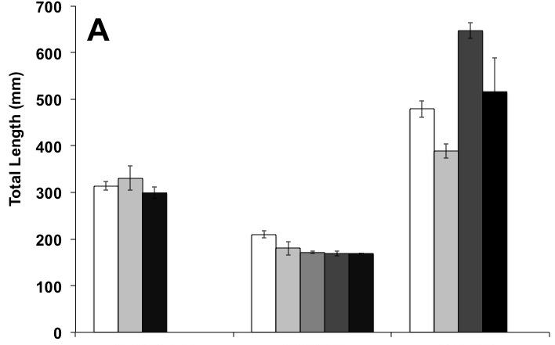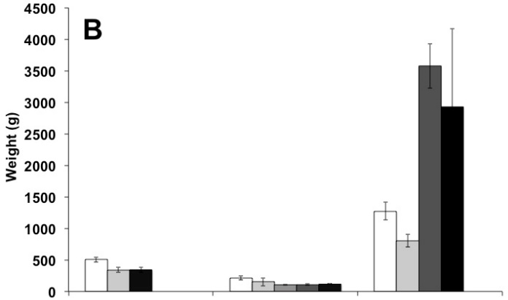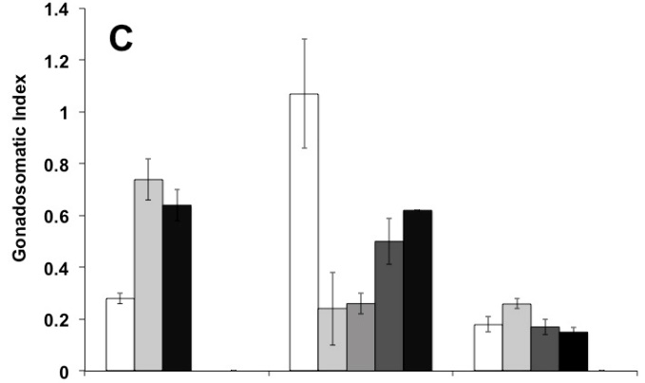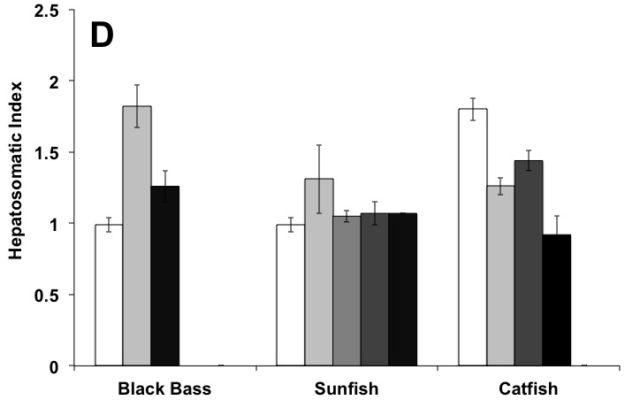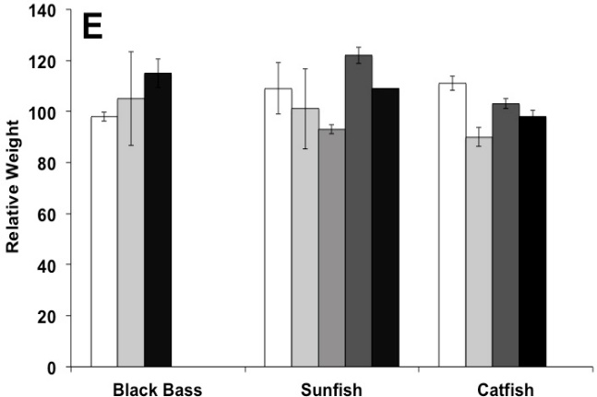

Figure SI 1. Total length (A), weight (B), gonadosomatic index (C), hepatosomatic index (D), and relative weight (E) by species (mean ± standard error). Largemouth bass (LMB, n=66), Smallmouth Bass (SMB, n=2), Spotted Bass (SPB, n=12), Redear Sunfish (RES, n=24), Warmouth (WAR, n=3), Bluegill (BLG, n=65), Redbreast Sunfish (RBS, n=19), Pumpkinseed (PKS, n=1), Channel Catfish (CHC, n=21), White Catfish (WHC, n=8), Blue Catfish (BLC, n=37), and Flathead Catfish (FHC, n=10).

